
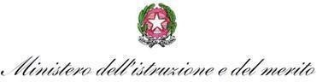
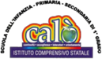

ISTITUTO COMPRENSIVO “G. CALÒ- G. DELEDDA- S.G. BOSCO”
di Scuola dell’Infanzia, Primaria e Secondaria di 1° Grado ad indirizzo Musicale
V.le M. D’UNGHERIA N. 86 -74013 GINOSA (TA) tel.+390998245663 –
C.F. 90283560739

REGISTRO DIDATTICO E DI PRESENZA

Progetti rientranti nel Piano dell'Offerta Formativa di lstituto
Anno Scolastico_______________

Titolo del Progetto _________________________________ Docente/i _______________________

La Dirigente Scolastica
Marianna Galli

Docente ___________________________________________________

DATA | ORARIO |  | ATTIVITÀ SVOLTE | FIRMA
DATA | DALLE ORE | ALLE ORE | ATTIVITÀ SVOLTE | FIRMA

RELAZIONE FINALE del docente Referente

_____________________________________________________________________________________________________________________________________________________________________________________________________________________________________________________________________

______________________________________________________________________________________________________________________________________________________________________________

______________________________________________________________________________________________________________________________________________________________________________

______________________________________________________________________________________________________________________________________________________________________________

______________________________________________________________________________________________________________________________________________________________________________

______________________________________________________________________________________________________________________________________________________________________________
….

Ginosa, ____________

FIRMA DEL DOCENTE

___________________________

